Bandit level 14 to level 15
To login to level 14 use the username as
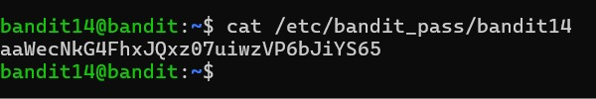
We will get the password for the next level 15

